**Kafrelsheikh University**

**Faculty of Computers and Information**

**Department of Information Technology**

**Smart Greenhouse Automation System based on IoT Technology**

A Graduation Project Presented to the

Department of Information Technology, Faculty of Computers and Information, Kafrelshikh University

in Partial Fulfillment for the Degree of Bachelor in Computers and Information

**Prepared By**

1. Ahmed Reda Elghonemy
2. Ahmed Sobhy Bekheet
3. Ahemd Maher AdulAziz
4. Osama Abdul-Raouf Esmaiel
5. Islam Mahrous Kareem
6. Abeer Ebrahiem Meckawi
7. Amr Karam Attya
8. Mohamed Hossam Eldeen
9. Mahmoud Elsaied Mohamed
10. Mahmoud Hamdy AbdulGany

**Supervised By,**Dr.Amr AboHany

Eng. Ahmed Gad

**2020**



### Acknowledgment

It is a pleasure to acknowledge many people who knowingly and unwittingly helped us, to complete our project. First of all, let us thank God for all the blessings, which carried us through all these years. We express our gratitude Dr. Amr Abo Hany, Eng. Ahmed Gad, and all colleagues for their cooperation and encouragement during the completion of this project. They enlightened as through the various stages during the development of the project and provided us with many insights and useful examples, which proved to be of immense help in successful completion of this project, which proved to be an immense of help for a successful completion of this project. We extend our sincere gratitude to our teachers and guide who made unforgettable contribution. We thank all the non-teaching staff of our faculty that was always ready to help in whatever way they could.

### Abstract

The Internet of Things is an emerging topic of technical, social, and economic significance. New agricultural applications in smart farming and precision farming through Internet of Things (IoT) will enable the industry to increase operational efficiency, lower costs, reduce waste, and improve the quality of their yield by creating a smart greenhouse. The smart greenhouse is a revolution in agriculture, creating self-regulating microclimate suitable for plant growth through the use of sensors, actuators, and monitoring and control systems. In this project, We intend to build an easy-to-use application that saves human effort and time as it helps user to know when crop need water instead of going to the place periodically. Also, it helps user to provide crops with its needs accurately without increasing or decreasing needs because both can cause damages to crops and Lower Operation Costs and save manpower as one farmer can watch more than one farm.

### Contents

**1. Introduction**

1.1 Introduction to project

1.2 Problem Statement

1.3 Objective

1.3.1 General objective

1.3.2 Specific objective

1.4 Scope

1.4.1 Smart greenhouse function (tasks)

1.4.2 Smart greenhouse components

1.4.3 System deadlines

1.4.4 System costs

1.5 Methodology

1.6 This project resets on

1.6.1 Speed

1.6.2 Expertise

**2. Related** **Work**

2.1 Introduction

2.2 Related work review

2.3 The old greenhouse system

2.4 The performance and services of the smart greenhouse system

2.5 Lesson learned

**3. Requirement Analysis**

3.1 Introduction

3.2 Hardware Specifications

3.2.1 Hardware Requirements

3.2.2 Software Requirement

3.3 Software Specifications

3.3.1 Functional requirements

3.3.2 Non- Functional requirements

3.3.3 Software tools

3.3.4 Advantage of the system

3.3.5 Performance requirement

3.4 Use Case Diagram

3.5 Sequence Diagram

3.6 System Activity Diagram

**4. System Design**

4.1 System Architecture

4.2 Context Diagram

4.3 Data Flow Diagram

4.4 Flow Chart Diagram

**5. System Implementation**

5.1 Application layers

5.2 Mobile Application

5.3 Hardware system

**6. Summaries**

6.1 Summaries

6.2 Benefits

6.3 Future Work

**7. Reference**

Content

***Chapter 1***

## Introduction

### Introduction

Technology dealings are fast gaining ground as an accepted and used life paradigm. More and more individuals are implementing applications providing functionality for performing practical needs over the mobile applications. It is reasonable to say that the process of getting technology in agriculture is becoming serious.

The objective of this project is to develop an agricultural land Control application where we can take control of crops, seeds, temperature and humidity from the comfort of home through the Internet. However, for implementation purposes, this paper will deal with an online android application in addition to some physical devices and wires.

Conventional greenhouses need regulated climate conditions to grow plants in there**.** Without an automatic control system**,** it is quite impossible to maintain the accurate climate conditions inside the green houses. Store each climate properties in a database for future analysis and to ensure remote monitoring to those data.

Internet of Things (IoT) is used for remote monitoring and analysis of data. In addition, an android application is developed to display those data in a short range through Bluetooth technology. The system measures the temperature, humidity, and light and soil moisture level by sensing the values from sensors.

This is performed by using some Functional components of the project such as Registration Screen that If the user is not registered, then registration screen should be available , Sensors that responsible for reading information about plants humidity and temperature and send them to the node MCU which makes some processing on these information before sending them to the firebase which store these information and send a notification to the mobile application that alert and give warning to the user . As well as the water motor which working as water pump to irrigate the plants in the greenhouse.

### Problem Statement

Green house is common project that we see in our life and it is source to earn money for many people but it works in manually way that consume time and effort of the farmer who take care of it So, we think to make an automatic system with IoT which will save that time and effort and will make it easy to provide quantity more than before with better quality.

The old system cannot be able to provide accuracy in the quantity of the water and if it was little or much amount it can harm plants .the system is time consuming and need more effort from farmer because everything that farmer make is manual not automatic. There is no accuracy in temperature measurements that can have effect on plants life. The system may be in remote location so may no electricity source so the solar power may be a solution for this problem.

### Objective

The objectives of the smart greenhouse system can be broken into two main objectives. The general objectives which determine and illustrate the general goals of smart agriculture, the second issue is specific objectives which illustrate and determine the goals of our system.

#### 1.3.1 General objective

Our general goal of that project is improving agriculture, increase the quantity of crops and therefore increasing the productivity, improve and enhance the quality of cops and help farmer who care crops to do it in easy way by decrease the effort and time that he needs to achieve these issues, the ability to adapt with the climate change so we found IoT would help us to enhance our life.

#### 1.3.2 Specific objective

Smart greenhouse help farmer or the one who is responsible for looking after the soil to know if soil or plants need water or no without going to their place. App helps him to know the degree of humidity anytime and anywhere and deal with it more carefully than before. App allows the accuracy in the amount of water which the soil and plants need without decreasing or overweight, As well as the accuracy in measuring the temperature and the remote controlling and access to the system of the smart greenhouse.

### Scope

By using the IoT technology to develop the greenhouse through controlling and monitoring smart greenhouse system by using a mobile phone so the smart greenhouse scope will explain and discuss the following issues.

#### Smart greenhouse function (tasks)

This system enables the connection between sensors and node MCU with the firebase and mobile application. Sensor can measure the temperature and humidity and send the information to node MCU to make some processing on it and upload the result to the firebase the store these information and send it to the mobile application.

#### Smart greenhouse components

The components of our system starts with sensors and terminates with mobile application in case of sending some measures to the mobile application, and vice versa in case of controlling the user in something in the smart system, so smart greenhouse components are sensors, water motor for irrigation and water pumping to the soil, Node MCU, Fire base, Mobile application.

#### System deadlines

Our project will take about six months to implement and publish it-

* Learning and studying the IoT technology in two months.
* Write the documentation of the project in one month.
* Construct the system hardware in two months.
* Testing and maintenance of the system in one month.

#### System costs

The smart greenhouse system cost 775 L.E. which is divided into some components as follows:

1. NodeMCE (ESP8266 Wi-Fi Programming & Development Kit).
2. Soil Moisture Sensor- Water level**.**
3. DHT11 (Temperature Humidity Sensor)**.**
4. L298 Motor Driver Module**.**
5. Water pump 9V**.**
6. Connectors and Leds.
7. Breadboard.
8. power supply.

### Methodology

The following are some of the main procedures that are followed to work the project:

* Learning experience from other projects that have used smart green house.
* Studying the current greenhouse system to get the requirement of the system.
* Study the IoT technology and how we use to implement this project.
* Assessing the requirements based on the previous steps and starts the analysis step.

### The project base

This project is mainly based on:

* A strategy where we architect, integrate and manage technology services and solutions.
* A focus on the use of reusable frameworks to provide cost and times benefits.
* They combine the best people, processes and technology to achieve excellent results consistency.
* We offer customers the advantages of:

#### Speed

They understand the importance of timing, of getting there before the competition. A rich portfolio of reusable, modular frameworks helps jump-start projects. Tried and tested methodology ensures that we follow a predictable, low-risk path to achieve results. Our track record is testimony to complex projects delivered within and evens before schedule.

#### Expertise

Our teams combine innovative technology skills with rich domain expertise.

What is equally important, they share a strong customer orientation, which means they actually start by listening to the customer. They are focused on coming up with solutions that serve customer requirements today and anticipate future needs. In term of programming skills, our team has combination of programming language such JAVA, C#. In addition to IoT technology, other skills include Communication skills, Marketing skills, Teamwork, Convince the client skills. Our team had implemented different projects inside and outside college.

***Chapter 2***

## RELATED work

### 2.1 Introduction

This chapter illustrate the important differences between our system (smart greenhouse system) and other old greenhouse system and some features that make the smart greenhouse distinct from the old one, So we focus on using the history of greenhouse and the first greenhouse in the history of the human is built in the roman era to grow the cucumber to be introduce to the king by introduce the cucumber to the sun all day and at the evening cover the cucumbers plants to make it warm. Hence the story of the greenhouse began .the idea of the greenhouse is developed in Europe especially by many botanists such as Leiden, Holland, during the 1800s.

The development stage of the greenhouse was not stop until the appearance of the IoT technology which makes anything in the world is very easy to use and the monitoring and controlling phase remotely only by using the smart mobile phone.

### 2 Related work

The smart greenhouse is a revolution in agriculture, creating a self-regulating, microclimate suitable for plant growth through the use of sensors, actuators, and monitoring and control systems that optimize growth conditions and automate the growing process. The French botanist Charles Lucien Bonaparte is often credited with building the first practical modern greenhouse in Leiden, Holland, during the 1800s to grow.

Another one of the latest promotions or updates in this topic was Farming Orchids which is the most successful form of precision farming in Taiwan, and also the most exported flower.

Orchids need a specific temperature and humidity conditions to grow and bloom, and its flowering time may not be in line with market demands, so the price collapses when there is overproduction.

Therefore, some farmers began to import automated greenhouse control systems for breeding and forcing, which not only improves quality, but also effectively controls the production period and yield to ensure revenue.

In 2012, an orchid farmer built a Forcing Greenhouse of about 200 pings (approximately 661 Square Meters) in Tainan, Taiwan. The system integrator adopted Advantech’s APAX-5000 series programmable automation controllers to build the control platform, coupled with Advantech Web Access HMI/SCADA software, to achieve cloud monitoring.

The staff of the orchid field can monitor important data anytime via smart phone, iPad, and other handheld devices, and control the growth and flowering conditions.

Also there are innumerable projects presented in this field all around the world and in a lot of countries seeking to increase its greenhouses productivity and reduce the use of water and efforts in it.

A greenhouse is designed to trap heat from the sun's rays inside and acts to keep the plants inside warm, even when it is cold outside. Today, entire crops and fields utilize greenhouse technologies to produce more food with higher crop yields.

Food growers can reduce or eliminate the use of harmful pesticides, which is essential for organic farming. Greenhouses protect plants from adverse weather events such as hail, snow, and intense heat.

### 2.3 The old greenhouse system

A greenhouse is a building with glass walls and a glass roof. Greenhouses are used to grow plants, such as tomatoes and tropical flowers. A greenhouse stays warm inside, even during the winter. In the daytime, sunlight shines into the greenhouse and warms the plants and air inside.

The old system cannot provide accuracy in the quantity of the water that can harm plants and this is based on farmer discretion, plus time consuming from the farmer or user to take care of plants.

The existing greenhouse requires more efforts from the farmers and not supports remote control. In a greenhouse the user can do any task such as monitoring the climate conditions in the green house, watering plants and the security issues manually or by himself. As well as if it is found a problem or errors ratio even if it is simple will harm the life of plants and the soil and causes heavy losses.

From the problems in the old greenhouse the experience of the agriculture if the user is not a farmer (he does not have an experience in agriculture field) will face a lot of difficulties because there is no quality and accuracy in everything and everything is manual.

### 2.4 The performance and services of the smart greenhouse system

The smart greenhouse provides the largest amount of plants, fruits and vegetables because it seeks to provide the ideal climate environment to allow the plants to grow on it. The system provides accurate temperature, humidity and water level measurements.it execute any tasks with high speed of response so it reduces the execution time.

The smart green house is considered extremely better than the older system. Provide many ways or techniques to achieve the security in the smart greenhouse system and provide high efficiency. Reducing the error rate in measuring process and provide availability of data anytime.

Using this smart greenhouse system, you can do more but with little time and effort. You can water plants, control the humidity and temperature only with using mobile phone or tablet.

Smart phone enables the users through mobile application to control the greenhouse through a modern technique known as IoT which is the Interconnection of number of devices through internet, every object is connected with each other through unique identifier so that data can be transferred without human to human interaction.

It allows establishing solutions for better management of natural resources. The smart objects embedded with sensors enables interaction with the physical and logical worlds according to the concept of IoT.

In this way we will connect the sensors with Node MCU to carry out processing on the sensor measurements and provide results. These results will be sent to smart phones as a notification by using firebase that store this information which is sent as signal that carry the message of the node MCU to the mobile application to alert the users.

Cloud Computing is an attractive solution to the large amount of data generated by the wireless sensor network. This project proposes and evaluates a cloud-based wireless communication system to monitor and control a set of sensors and actuators to assess the plants water need.

The administration of the water system can be enhanced utilizing controlled watering system this project proposes a controlled water system with data about crops humidity levels which will reduce manual labor and optimizing water usage increasing productivity of crops.

This system will provide the user with some important information and recommendation that makes the agriculture process is based on the efficiency and high quality as well as achieves a lot of benefits and incomes so the user is not necessary to be a farmer.

### 2.5 Lesson learned

One of the most important lesson learned is using new technology is called IoT. This technique saves more time and effort, allows us to use affordable wireless technology and transmit the data into the cloud at a component level. It also provides a place to save data as well as management and security.

IoT devices can be used to monitor and control the mechanical, electrical and electronic systems used in various types of buildings. IoT its return will promote efficiency in performance, economic benefits and minimize the need for human involvement. It's the most important development of the 21st century.

Other thing is Cloud Computing which is an intelligent solution for storing and retrieving data read by sensors and uploaded to firebase, and this helped us a lot in made it very easy to control the flow of data and not to be worry about data storing problem.

***Chapter 3***

## REQUIREMENT analysis

### 3.1 Introduction

This chapter analyzes the previous problems and understands its context through the activity of talking about the system requirements and domain of the new system, this activity is very important because it leads to a successful design of the new system (proposed system). Understanding the characteristics and requirements of a new system is more difficult and requires creative thinking and understanding of existing running system is also difficult, because if there is a misunderstanding of analyzing the proposed system, it can lead diversion from solution .This follows a specific or certain steps in the WATER FALL model that begin from the requirement analysis and terminates to delivery and maintenance of the system.

### 3.3 Hardware Specifications

#### 3.2.1 Hardware Requirements

* Humidity sensors
* Node MCU
* Water pump (water motor)
* Board
* Temperature sensor
* Wires and leds

#### 3.2.2 Software Requirement

* C programming language
* Android studio 2019
* Firebase
* Java

### 3.3 Software Specifications

#### 3.3.1 Functional requirements

Functional requirements describe what a system should do. The functional requirements of our system are explained below User must have a valid User ID and Password to login thus creating their individual profile. Every user profile is stored in database. Administration can make control of the application for updating it. Sensors can measure the humidity and the temperature that are considered important information. This information is sent to Node MCU to make processing on it; thus, the result is sent to the firebase to be stored.

Node MCU device sends this result to mobile application to alert the user. Mobile application can provide the users with some information that enables them to take a background about agriculture and some crops. Water motor is considered motor pump to pump the water in case of the soil or plants need some water. Maintain the humidity degree at a certain level if it is decreased, the application sends to the Node MCU to turn on the water motor. Maintain the temperature degree at a certain level if it is decreased, the application send data to Node MCU to turn on the heater.

#### 3.3.2 Non- Functional requirements

Requirements that can be used to judge the operation of a system are called Nonfunctional requirements. Non-functional requirements of our system are explained below:

* Secure access of a confidential data.
* Provide availability.
* Better components design to get efficiency at peak time.
* High response time.
* Low execution time.
* Flexible service to benefit the user in the present and future time.
* High performance.
* High quality and efficiency operation

#### 3.3.3 Software tools

* Database server (firebase).
* Development tools (android studio 2019).
* Programming language (Java and c programming languages).
* Client android application.

#### 3.3.4 Advantage of the system

* Provide accurate information.
* Provide availability.
* Security.
* High efficiency.
* Reduce the error rate in measuring process.

#### 3.3.5 Performance requirement

Define how well the system performs certain functions under specific conditions:

* The system should be accurate.
* The system should execute any functions with high speed of response.
* The system should reduce the execution time.
* The system should be better than the existing system
* The system should not contain any errors that may be effect on the performance

### 3.4 Use Case Diagram

Fig.1. Use Case Diagram

When we explain this graph (Fig.1), we will explain how to use this project and find that only one person (user) controls the system, so we prove that IoT technology saves time, effort, and even money that the user spends on some workers to take care of plants and crops until we find the user only registers to create an account Or log in to the mobile application to interact with the system, and give some data or orders, and then leave most of the things to the system to implement, we find that Node MCU Module transmits data and results from the fittings to the application for display to the user and then uses the instructions entered into the application by the user to control the machines.

### 3.5 Sequence Diagram

This diagram (Fig.2) shows all actions that the system does but in sequence flow or sequence steps. Sensor sensing the data that is transmitted to node MCU Arduino, this Arduino can store this data on firebase or the firebase request the data from the node MCU, after that the firebase transmits this data to the application.

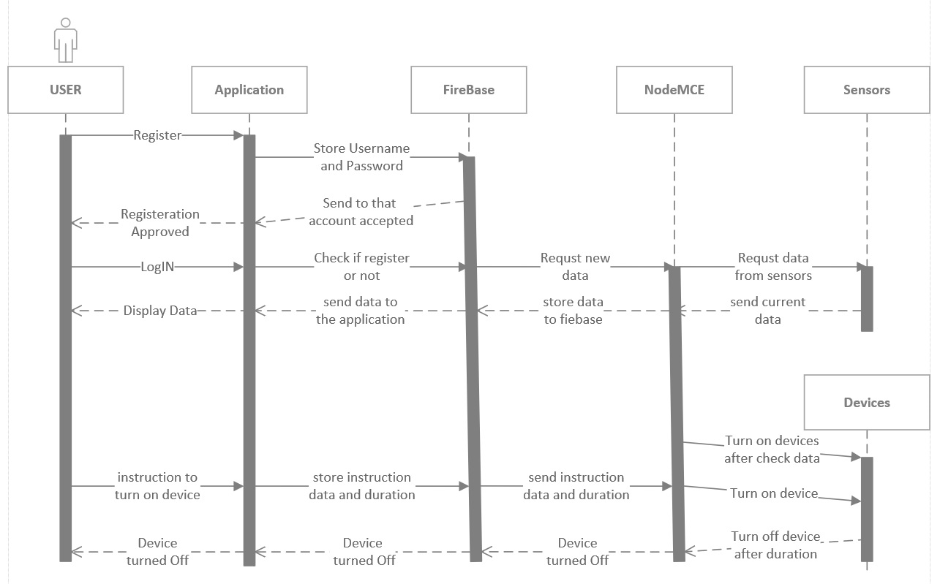



### 3.6 System Activity Diagram

***Chapter 4***

## System design

### 4.1 System Architecture

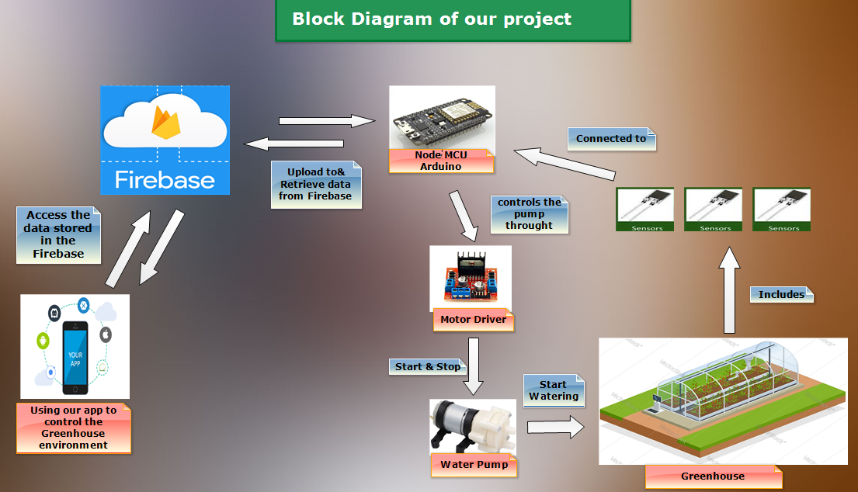

Fig.5. System Architecture

This diagram (Fig.5) shows how the system work but in simple form that facilitate the user understanding to all component of the system and how he/she is able to interact with each component. When the sensors notice that the humidity degree of the soil is decreased until reaches to a certain level. Then the Arduino sends a notification to the firebase to deliver this notification to the mobile application that alert the user to turn on the water pump. When the user does this, this action reaches to the Arduino through firebase to turn on the water pump for irrigation.

### 4.2 Context Diagram

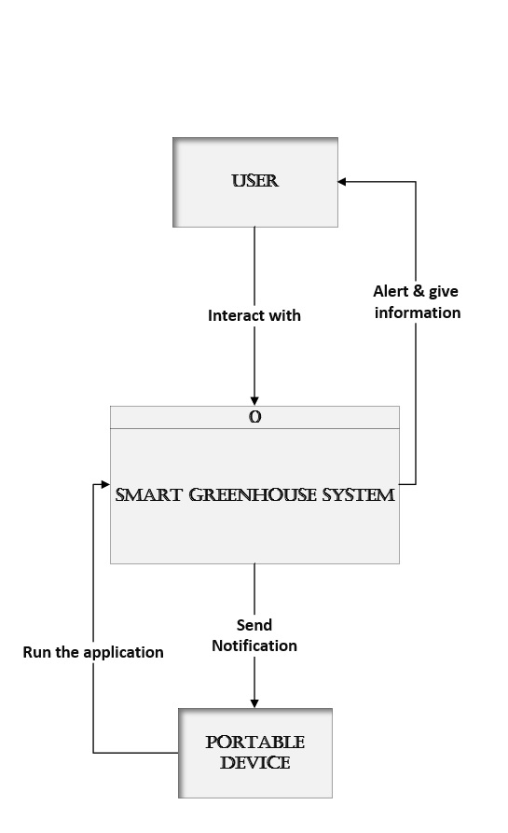

Fig.6. Context Diagram

This diagram (Fig.6) considers the first step of the DFD diagram that shows the external entities and how these entities interact with the smart greenhouse system. Mobile device run the mobile application and receives a notification from the system to alert the users. The users interact with the system and the system supplies them with more information and alerts them.

### 4.3 Data Flow Diagram

First, the sensor senses and measure the degree the humidity to store in Arduino ram. Second, the Arduino make processing to calculate the humidity and show the results in Arduino screen. Third, the Arduino send a notification to the mobile application that alert the user who created the account on the application that there is a warning or problems or even a recommendation about how the smart greenhouse works.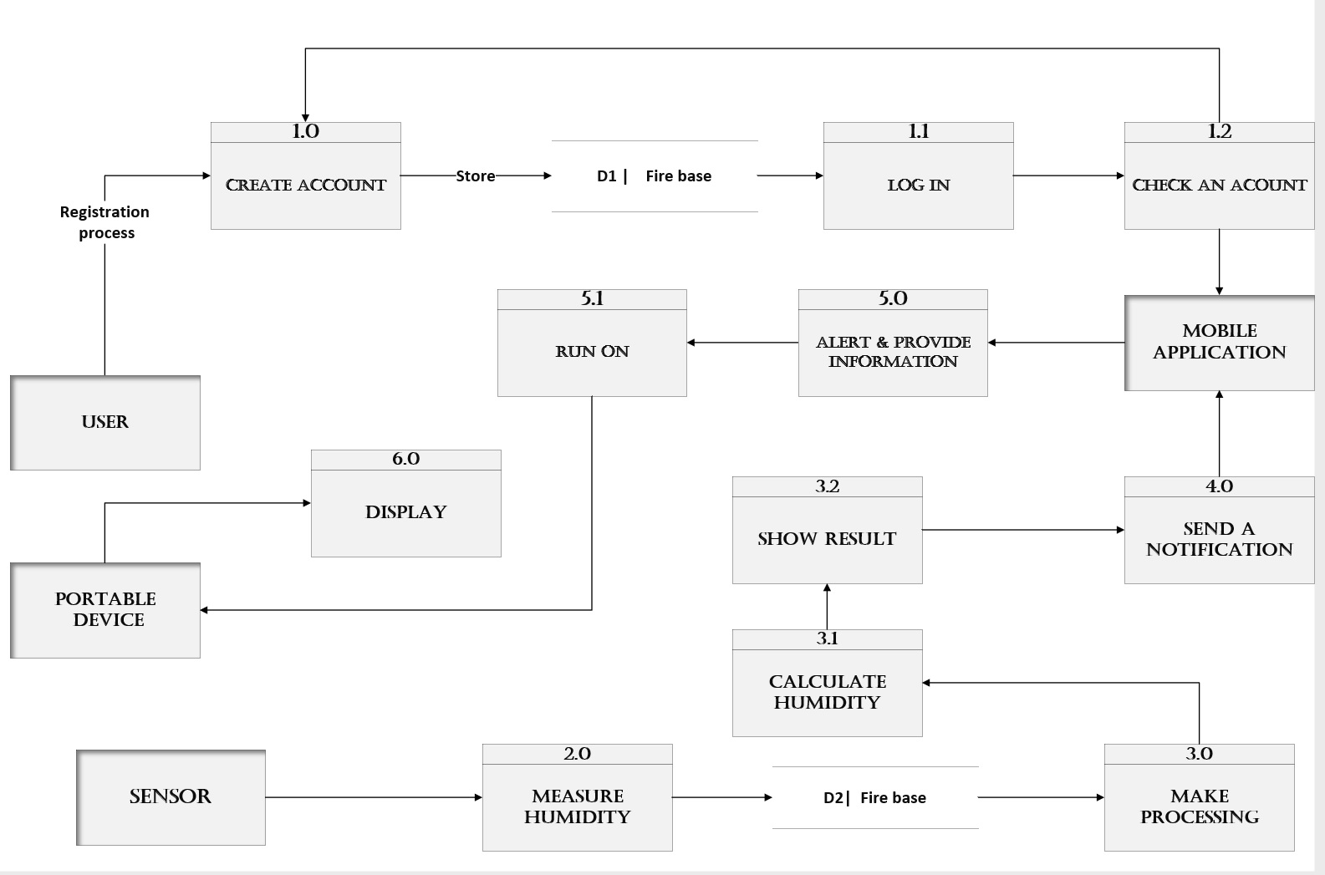

Fig.7. Data Flow Diagram

### 4.4 Flow Chart Diagram

In this diagram (Fig.8) we notice that the system starts with login if you have not an account you have to sign up to be able to access to the application. After that, the access process is implemented for two reasons. The first, the users receive a notification that alerts them to make decision. The second, the users interact with the application such as choose the season so the application provide them with some plants that is recommended to be grew. After that if, the soil need water the smart irrigation started if not the application end.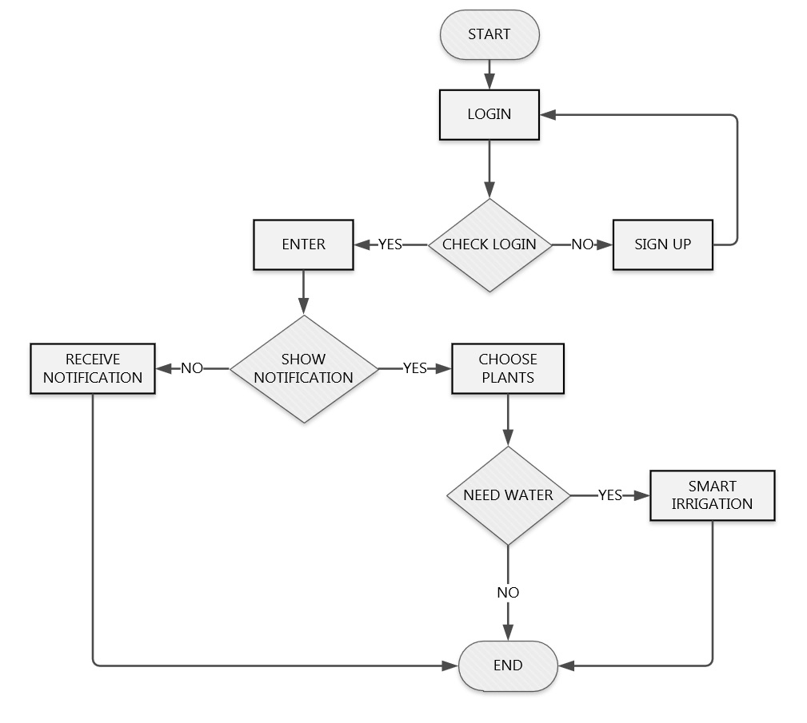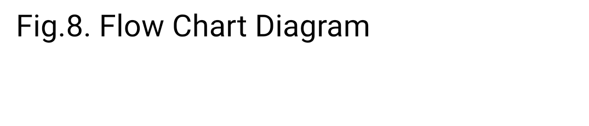

***Chapter 5***

## System Implementation

### 5.1 Application layers

Application layers is one of the most important diagrams because it show which programming language each layer uses .from platform layer to application layer we find that the operating system or the Arduino uses the (c) programming language after that the cloud environment that store data and exchange the information from and to the mobile application(firebase). Then the application framework that is considered as the platform of the application is android studio. We reach the top of the diagram that represent the mobile application which use JAVA, XML programming language.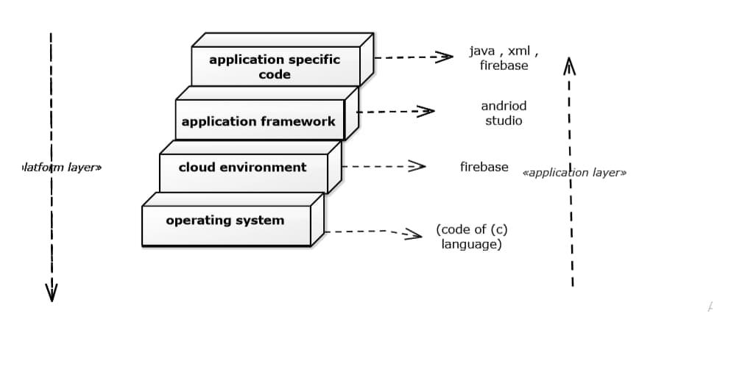

Fig.9.Application Layer

### 5.2 Mobile Application

**Splash Screen Activity**

Splash screen is introduction activity have the logo and the name of the application.

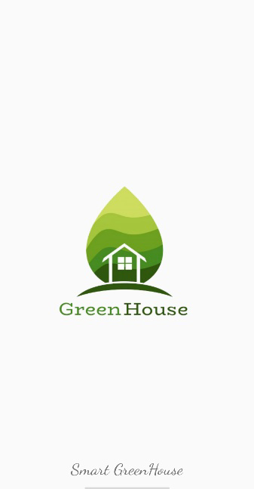

**Registration Activity**

Through the registration page the user must register to the app with the username, email and password, and can use this email and password to login again to app and have account. We add show password and confirm password to facilitate sign up to the application. If you are register you can login through the link at the bottom of the page.

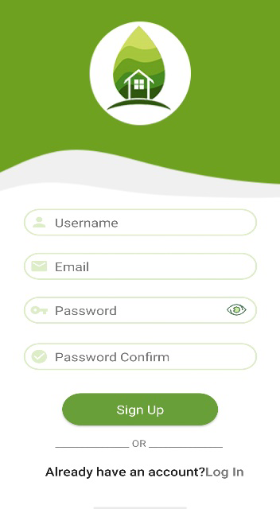

**Login Activity**

The Login page is the first page appears to user after splash screen. Then user can enter the email and password to login application, after entering the Home page will be opened. If you are not register you can register through the link at the bottom of the page, and add show password to facilitate login to the application.

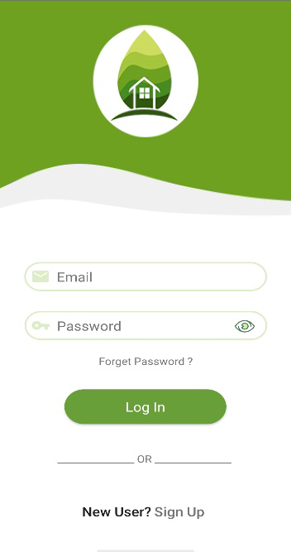

**Home Activity**

It is the main page in the application contain a group of icon are responsible for opening other pages. Each of these icons is responsible for user's news with some information about the application and enabling the user to adjust and monitor the greenhouse settings and crops. And from the three dots the user can to log out from application or go to the about.

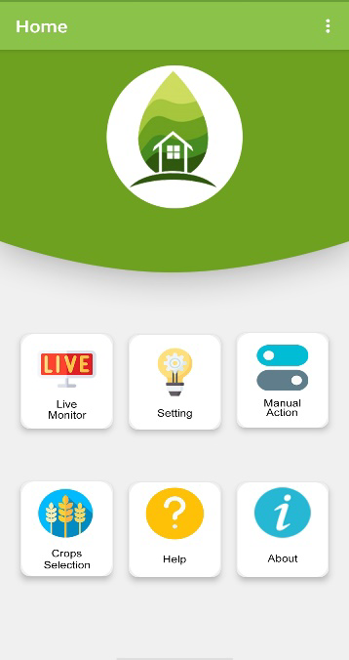

**Live Monitor Activity**

On this page see the percentage of the soil moisture and temperature through the measurement of the sensors. Based on these measurements, the user will be able to choose the appropriate crop and protect it from weather changes. All this information helps to increase production and monitor the state of crops.

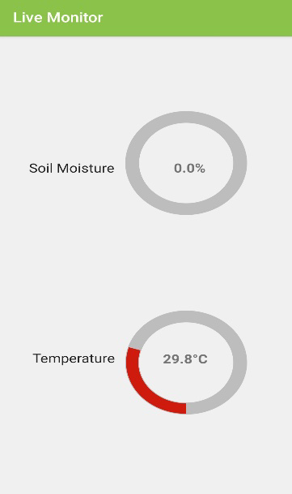

**Crop Selection Activity**

On this page the user can select one of the available crops. When selecting the crop, the appropriate time to grow this crop will appear and determine the end date for harvesting the crop based on the date of the day the crop was chosen. The user can change the start and end date and save these changes to the database.

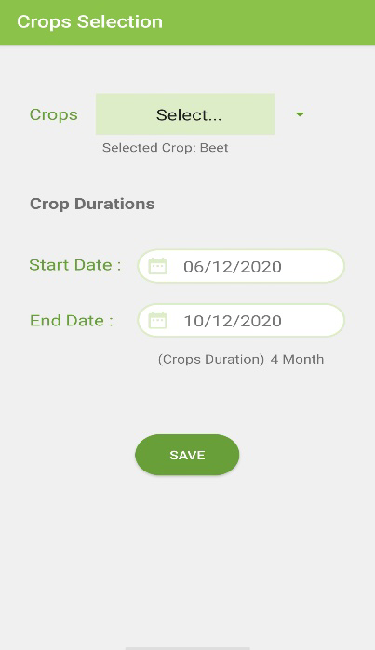

**Setting Activity**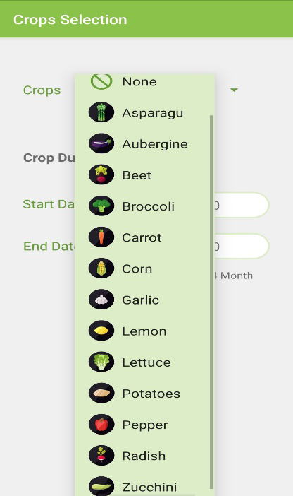

On this page, we will display to the user the selected crop on the crop selection page, and if the user does not choose a crop, a link will appear for the user to transfer to the access selection page to select crop. And also display the best degree of humidity and temperature for the selected crop to save crops from weather changes.

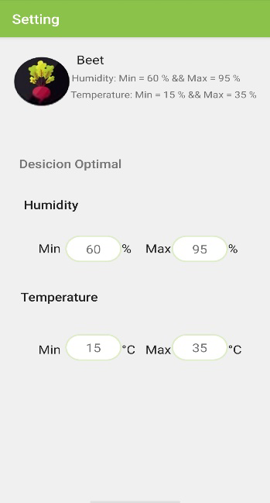

**Manual Activity**

On the manual control page, the user is shown the temperature and soil moisture. The user can select if he wants to open the water motor when the humidity is low or turn the leds on when the temperature drops. When the user wants to start the motor or leds, it is possible to specify the time that remains open before pressing the power button. The user can press the stop button before the timer end to stop or pause motor or turn off the led.

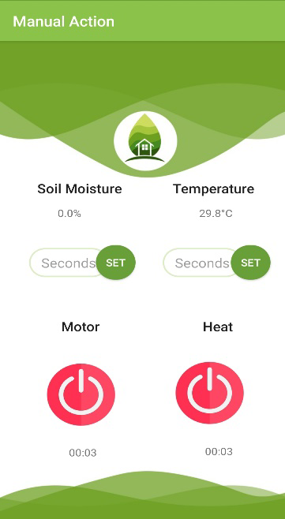

**Help Activity**

This page helps the user to get to know the application and know the function of each page, how to use it and what information it displays in order to facilitate the user to deal with the application.

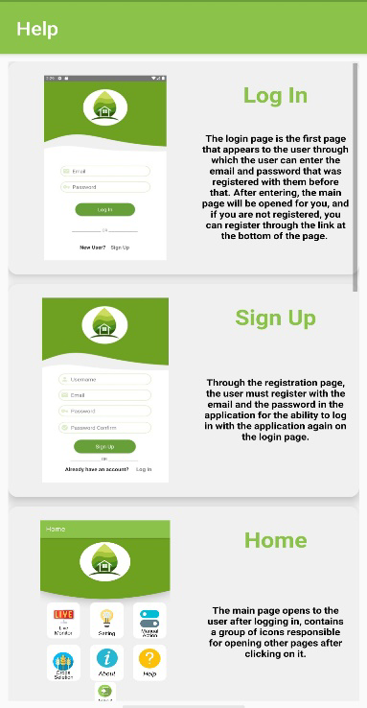

**About Activity**

Here we talk about who we are and what the application we have, the functionality of it and the methods of communicating with us through which the user can communicate with us by email or phone number.

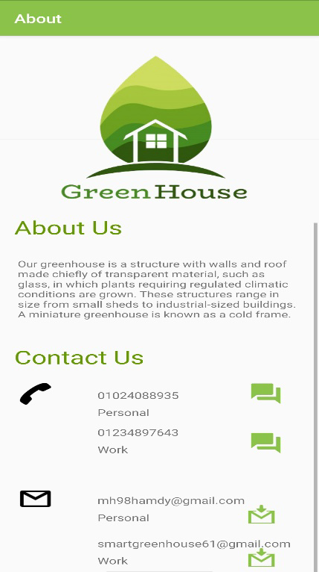

**Firebase Connection**

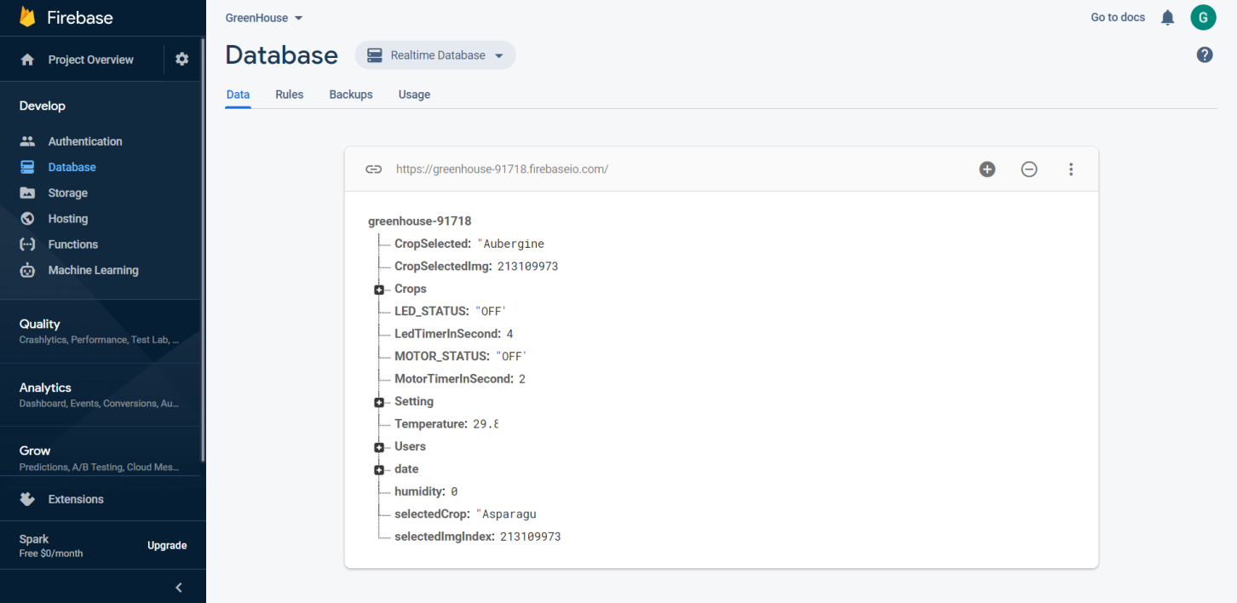

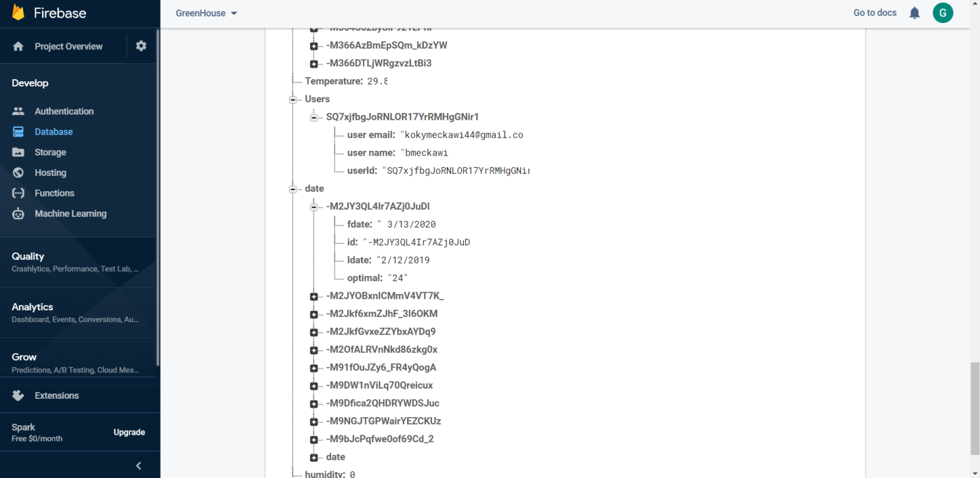

### 5.3 Hardware system

**Hardware requirements**

1. **NodeMCE (ESP8266 Wi-Fi Programming & Development Kit):**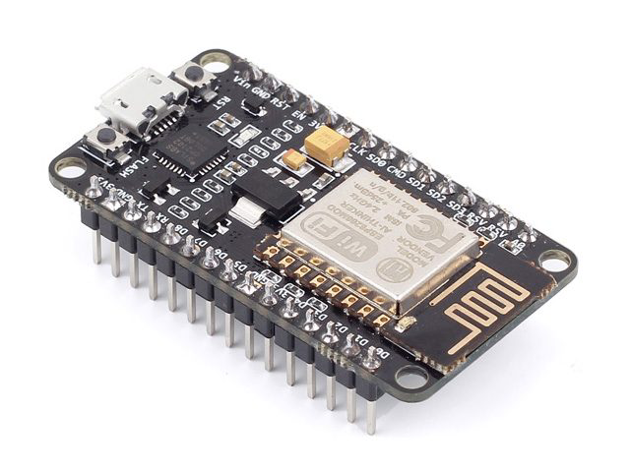

NodeMCU is an open-source firmware and development board that helps you to prototype your IoT product with a few Lua script lines. The development board is based on the ESP8266 Wi-Fi chip with 10 GPIO and 1 ADC input. Each GPIO can be used as PWM, I2C, SPI and 1-Wire. Via the micro USB you can program NodeMCU.

The advanced API for hardware IO uses interactive Lua script which is like Arduino code. The event-driven API for network applications facilitates developers writing code in Nodejs style. It speeds up your IoT application developing process.

Because of the presence of the Wi-Fi or the antenna feature, we can connect to the Internet and perform some important operations:

1. Receiving the data and readings extracted, whether from the soil or the air temperature, using the dedicated sensors to carry out these operations.
2. Sending these readings and extracted data to the so-called Firebase to store and then display them on the mobile application.
3. Carry out some treatments, which allow the automatic operation of the water motor if needed, or turn on the air conditioning.
4. Sending orders received from the user through the mobile application and sending them to the motors.
5. **Soil Moisture Sensor- Water level:**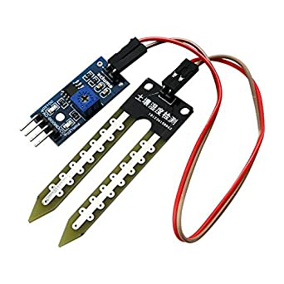

This Moisture Sensor uses Immersion Gold which protects the nickel from oxidation. Electroless nickel immersion gold (ENIG) has several advantages over more conventional (and cheaper) surface plating’s such as HASL (solder), including excellent surface planarity (particularly helpful for PCB’s with large BGA packages), good oxidation resistance, and usability for untreated contact surfaces such as membrane switches and contact points.

This Moisture Sensor can read the amount of moisture present in the soil surrounding it. It’s a low tech sensor, but ideal for monitoring an urban garden, or your pet plant’s water level. This is a must have tool for a connected garden!

This Moisture Sensor can be used to detect the moisture of soil or judge if there is water around the sensor, let the plants in your garden reach out for human help. They can be very to use, just insert it into the soil and then read it. With help of this sensor, it will be realizable to make the plant remind you. Hey, I am thirsty now, please give me some water.

This Moisture Sensor uses the two probes to pass current through the soil, and then it reads that resistance to get the moisture level. More water makes the soil conduct electricity more easily (less resistance), while dry soil conducts electricity poorly (more resistance).

1. **DHT11 (Temperature Humidity Sensor):**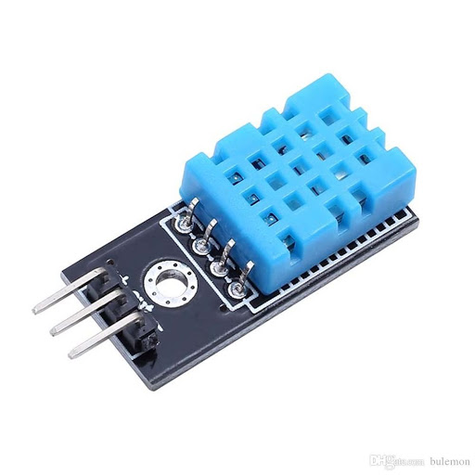

DHT11 sensors are very basic and slow, but are great for hobbyists who want to do some basic data logging. The DHT sensors are made of two parts, a capacitive humidity sensor and a thermistor. There is also a very basic chip inside that does some analog to digital conversion and spits out a digital signal with the temperature and humidity. The digital signal is fairly easy to read using any microcontroller.

The DHT11 is a commonly used Temperature and humidity sensor. The sensor comes with a dedicated NTC to measure temperature and an 8-bit microcontroller to output the values of temperature and humidity as serial data. The sensor is also factory calibrated and hence easy to interface with other microcontrollers.

The sensor can measure temperature from 0°C to 50°C and humidity from 20% to 90% with an accuracy of ±1°C and ±1%. So if you are looking to measure in this range then this sensor might be the right choice for you.

1. **L298 Motor Driver Module:**

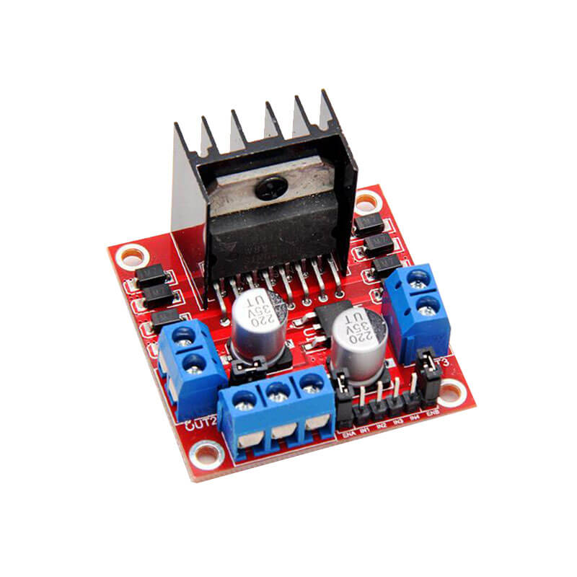

Double H driver module uses ST L298N dual full-bridge driver, an integrated monolithic circuit in a 15- lead Multiwatt and PowerSO20 packages. It is a high voltage, high current dual full-bridge driver designed to accept standard TTL logic levels and drive inductive loads such as relays, solenoids, DC and stepping motors. Two enable inputs are provided to enable or disable the device independently of the input signals. The emitters of the lower transistors of each bridge are connected together and the corresponding external terminal can be used for the connection of an external sensing resistor. An additional supply input is provided so that the logic works at a lower voltage.

We use this piece to control the water pump motor, so we can give orders and supplies when it works, when it closes, and for the specific time that the motor must remain running.

1. **Bread Board:**

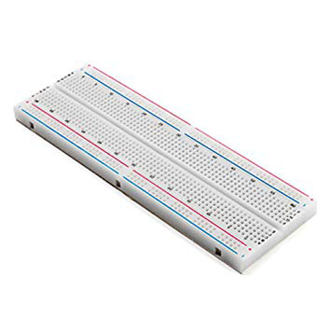

6- **Water pump 9V:**

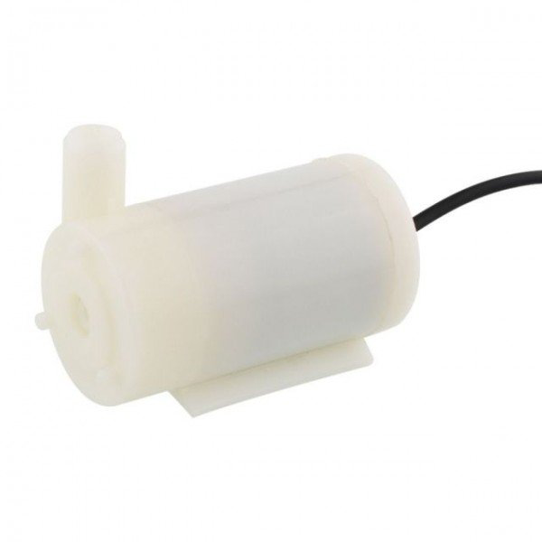

7- **Power supply:**

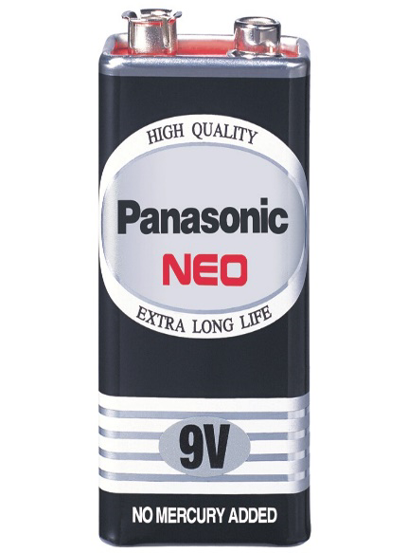

8- **Connectors and Leds:**

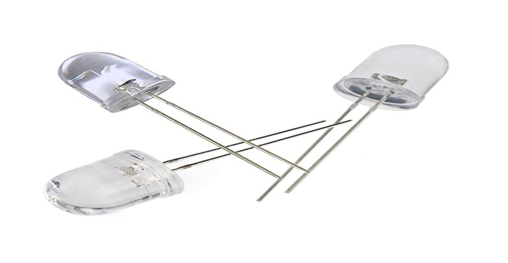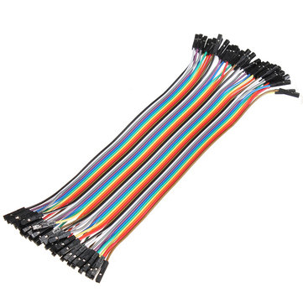

**System Implementation**

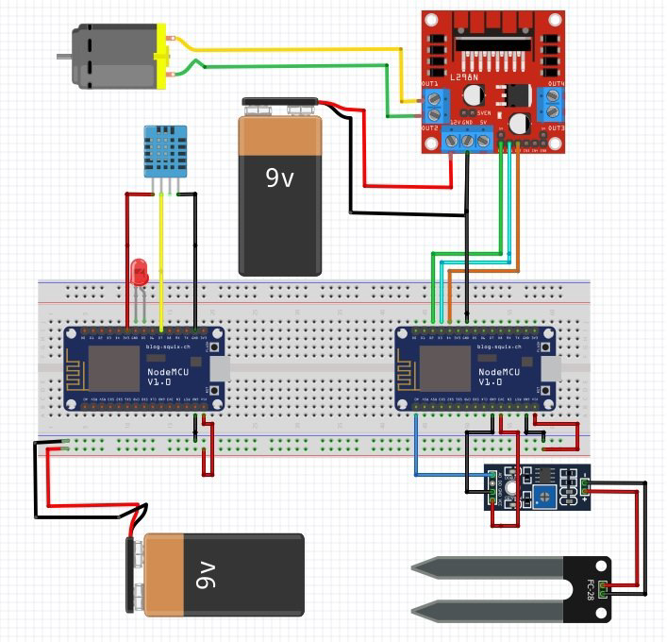

***Chapter 6***

## SUMMARIES

### 6.1 SUMMARIES

The Internet has become a major resource in the life and modern technology focus on internet in everything shopping, education, entertainment, work, travelling, tourism, etc. IoT became an important field that has many advantages as it saves human time and effort and help him to has accuracy in the work as it helps human to make this work with right way and in the right time So we thought to use it in agriculture to help farmer to make his work with the rightest way so he can produce crops at their best condition with the help of an android application which is connected wirelessly with Arduino that take information about crops using sensor then send this information to the mobile application which gives notifications to the user to know what the crops need.

To implement this android application, we used android studio as the Technology. Android studio has several advantages such as enhanced performance, scalability, built- in security and simplicity. To build any android application using android studio we need a programming language such as java and Kotlin, and in our application we used java.

Android is an open source and Linux-based Operating System for mobile devices such as smartphones and tablet computers. Android was developed by the Open Handset Alliance, led by and is managed or maintained by Google and other companies. Android offers a unified approach to application development for mobile devices which means developers need to develop only for Android, and their applications should be able to run on different devices powered by Android.

On top of smart technology being an effective solution, the Internet of Things is also helping people make their activities rapidly so it is freeing up time for other activities, so for the Arduino programming we used C language. In addition, sensors have information about crops and the humidity of the soil.

User should be able to know at which season of the year we can plant that crop and what the amount of the water it needs. It has been a great pleasure for us to work on this exciting and challenging project. This project proved good as it provided practical knowledge of not only programming in java and C but also about all handling procedure related with our secure android and IoT app, it also provided knowledge about the latest technology used in developing android application.

### 6.2 Benefits

As in other industries, the application of the Internet of Things in agriculture promises previously unavailable efficiency, reduction of resources and cost, automation and data-driven processes.

The benefits are as follows:

* It is easy to use
* Save human effort and time as it helps user to know when crop need water instead of going to the place periodically.
* Water Conservation It helps user to provide crops with its needs accurately without increasing or decreasing needs because both can cause damages to crops.
* It helps user to notice his crops anytime anywhere using mobile application.
* Lower Operation Costs and save manpower as one farmer can watch more than one farm.
* Control infection and avoid diseases outbreak in crops
* Increase the productivity of the plants and incomes
* Provide the high performance of the system and high quality of the measurements.
* Remote Monitoring Provide easy user interface of mobile application for controlling and access to every part in the system.
* Accurate Farm and Field Evaluation.

### 6.3 Future Work

Our team hopes to update the system later to be able to making Internet of Things help users to turn the lights on and off, lock the windows to control the amount and percentage of Oxygen and Carbon dioxide. Water plants automatically, develop the system to achieve better yield rates.

Smart greenhouses are capable of controlling and optimizing environmental factors that affect crops like temperature, ventilation, Smart greenhouses, enabling crop growers to step away from their greenhouses but still control its climate with the touch of a button.

IoT sensors in smart greenhouses provide an affordable infrastructure to monitor door status and detect suspicious activities. Connected with an automated alarm system, that notifies growers when a security issue arises.

## REFEReNCEs

### References

1. https//www.amphenol-sensors.com/en/product-spotlights/3451-indoor-agriculture-smart-greenhouses?gclid=Cj0KCQjw9b_4BRCMARIsADMUIyrJcHsbil8cE-0ECQeU-mSOgKrNgIq_dTUrQ-PxAKw0aJb9_xoU-S8aAvGEEALw_wcB
2. [https//www.designingbuildings.co.uk/wiki/Smart_greenhouse](https://www.designingbuildings.co.uk/wiki/Smart_greenhouse)
3. [https//deprolabs.com/blog/smart-greenhouse-changing-agriculture/](https://deprolabs.com/blog/smart-greenhouse-changing-agriculture/)
4. [https//behrtech.com/blog/4-benefits-of-smart-greenhouses-and-how-to-get-started/](https://behrtech.com/blog/4-benefits-of-smart-greenhouses-and-how-to-get-started/)
5. [https//homeguides.sfgate.com/methods-decrease-temperature-greenhouse-21620.html](https://homeguides.sfgate.com/methods-decrease-temperature-greenhouse-21620.html)
6. [https//www.postscapes.com/smart-greenhouses/](https://www.postscapes.com/smart-greenhouses/)
7. [https//www.researchgate.net/figure/Use-case-diagram-of-the-ubiquitous-greenhouse-system_fig7_51873338](https://www.researchgate.net/figure/Use-case-diagram-of-the-ubiquitous-greenhouse-system_fig7_51873338)
8. [https//internetofthingsagenda.techtarget.com/definition/Internet-of-Things-IoT](https://internetofthingsagenda.techtarget.com/definition/Internet-of-Things-IoT)
9. [https//www.zdnet.com/article/what-is-the-internet-of-things-everything-you-need-to-know-about-the-IoT-right-now/](https://www.zdnet.com/article/what-is-the-internet-of-things-everything-you-need-to-know-about-the-iot-right-now/)
10. [https//greenerideal.com/guides/13-advantages-of-growing-plants-within-a-greenhouse/](https://greenerideal.com/guides/13-advantages-of-growing-plants-within-a-greenhouse/)
11. [https//ieeexplore.ieee.org/abstract/document/6906517](https://ieeexplore.ieee.org/abstract/document/6906517)
12. [https//www.softwebsolutions.com/resources/smart-greenhouse-monitoring-solution.html](https://www.softwebsolutions.com/resources/smart-greenhouse-monitoring-solution.html)
13. [https//www.visual-paradigm.com/tutorials/how-to-create-data-flow-diagram/](https://www.visual-paradigm.com/tutorials/how-to-create-data-flow-diagram/)